

IT5/L – IT Elective 2

2798

**Dalandangan pizza**

Ordering System

Submitted to:

Renz Ariola

Submitted by:

Dalandangan, Nasrullah M.

October 2025

Table of Contents

The Dalandangan Pizza Ordering System ………………………………………………………1

Problem 1: Manual Order Taking Process……………………………………………………….2

Solution 1: Digital Menu Interface………………………………………………………………2

Problem 2: Order Status Tracking……………………………………………………………….3

Solution 2: Real Time Order Tracking………………………………………………………….3

Problem 3: Payment processing and Receipt Management……………………………………...4

Solution 3: Digital Payment System…………………………………………………………….4

**Conclusion………………………………………………………………………………………5**

**Tools…………………………………………………………………………………………….6**

**Use Cases……………………………………………………………………………………….7**

**Entity Relationships Diagram (ERD)…………………………………………………………8**

**Data Dictionary…………………………………………………………………………………9**

**User Interface………………………………………………………………………………….10**

**References………………………………………………………………………………………11**

**List of Figures**

**Figure 1: Dalandangan Pizza………………………………………………………………………..5**

**Figure 2: Comparison of manual and digital order-taking methods……………………………...5**

**Figure 3: Real-time Order Tracking…………………………………………………………………6**

**Figure 4: Digital Payment System……………………………………………………………………..12**

**Figure 5: Dalandangan Pizza Use Cases………………………………………………………………13**

**Figure 6: Dalandangan Pizza ERD……………………………………………………………………14**

**Figure 7: Customer Registration Interface………………………………………………………15**

**Figure 8: Customer Menu Interface…………………………………………………………………..16**

**Figure 9: My Cart Interface……………………………………………………………………………..17**

**Figure 10: Checkout Interface………………………………………………………………………….18**

**Figure 11: Staff Panel Interface…………………………………………………………………………19**

**Figure 12: Cashier/Admin Panel Interface……………………………………………………………..20**

List Tables

Table 1: Costumer……………………………………………………………………………..10

Table 2: Transactions………………………………………………………………………….11

Table 3: Staff………………………………………………………………………………….12

Table 4: Transactions………………………………………………………………………….13

Table 5: Admin………………………………………………………………………………...14

Table 6: Transaction…………………………………………………………………………….14

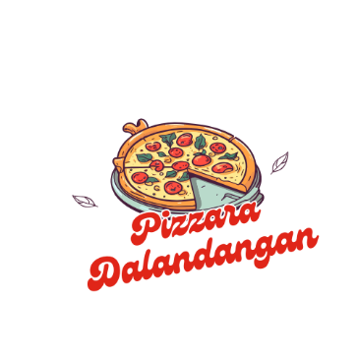

Figure 1: Dalandangan Pizza

Dalandangan Pizza

A lot of food businesses experience challenges in managing their food ordering operations. Many pizza shops struggle with orders because they don’t use digital systems, which results in no online menus, difficulty in managing menu changes, problems tracking orders and updating customers, and customer frustration from long lines, order mix-ups, and inconvenient payment processes. The Dalandangan Pizza Ordering System addresses these challenges by providing a digital food ordering platform that connects customers and the pizza store in one smooth process. Customers can view menus, place orders, pay easily, and track their food, while the store staff manage orders more efficiently, reduce mistakes, and improve customer satisfaction. With the Dalandangan Pizza Ordering System, ordering becomes simpler, faster, and more reliable for both the business and its customers. Additionally, digital ordering platforms like the Dalandangan Pizza Ordering System give pizza businesses useful insights into customer preferences, demand, and operations. These tools help manage inventory, staffing, and menu planning. In today’s competitive market, using technology is essential for growth and customer loyalty. The Dalandangan Pizza Ordering System enables the business to follow industry trends, strengthen its brand, and provide a dining experience that matches modern customer expectations [1].

**Problem 1: Manual Order Taking Process**

Manual order taking in restaurants causes customers and staff to experience operational inefficiencies. During peak hours, long queues delay both ordering and food service. These delays reduce customer satisfaction and decrease the likelihood of repeat visits. In addition, manual systems are often prone to human error, as orders may be misheard, forgotten, or duplicated. This leads to inaccuracies, customer dissatisfaction, wasted resources, and revenue loss for the business. Customers also become disappointed when, after waiting in line, they discover that the product they wanted has already run out. For students and professionals with limited mealtime breaks, long waiting times often prevent them from eating, which affects their well-being and reduces the restaurant’s sales. Overall, manual ordering decreases efficiency, increases errors, and harms the dining experience. These challenges highlight the need for digital order management systems, which can enhance operations, reduce mistakes, shorten waiting times, and improve customer satisfaction [2].

Figure 2**:** Comparison of manual and digital order-taking methods

**Solution 1: Digital Menu Interface**

A friendly digital interface through which customers can view the entire menu with real-time updates on availability. Customers can place orders directly via the system without having to stand in queues. Instantaneously, the system will show the description of the dishes, their pricing, and the availability status. For instance, the college student in the previous example can now order during break times while in class via their mobile phone and just collect it when ready. Thus, eliminating the time spent placing an order and reducing chances of human errors in taking orders. The system will allow customers to customize their orders (add or remove ingredients) and save their favorite combinations for future orders [3].

**Problem 2: Order Status Tracking**

Another serious challenge is a lack of order status visibility. Customers do not understand how long their food will take for preparation or when it will be ready for pickup and delivery. As a result, customers often bother the staff with inquiries, leading to anxiety from their end. This is especially true for takeout orders. Many customers have stated they call restaurants several times to check if their food is ready, pausing kitchen operations. A working professional mentioned that the lunch was mostly ordered but was unclear of when to flow from the office for pickup. Sometimes early, they would wait for the food; other times too late, and it was cold [4].

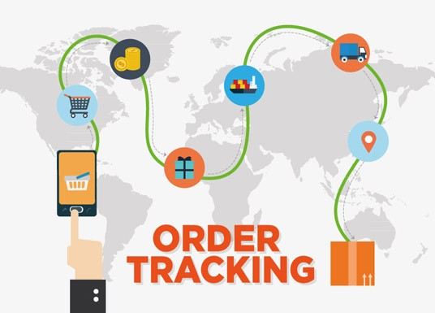

Figure 3: Real-time Order Tracking

**Solution 2: Real Time Order Tracking**

Based on figure 3, this approach provides **real-time order status tracking** by categorizing orders into **“Order Received,” “Preparing,” “Ready for Pickup,”** and **“Out for Delivery.”**. Automatic updates would be given to the consumers through the application at each stage. A few clicks from the kitchen staff will update the order status, while estimated preparation times are calculated automatically based on the current queue length. The working professional example has a notification sent when their lunch is done; giving them enough time to go pick it up at the perfect moment. This makes for less interruption of waiting staff and information on the ordering process improves customer satisfaction [5].

**Problem 3: Payment processing and Receipt Management**

Most restaurants still rely on **cash-only transactions** and **manual receipts**, which cause delays and accounting errors. Customers face inconvenience providing exact change, and slow payments lengthen queues. For staff, handling cash adds counting and reconciliation burdens and increases the risk of errors. Paper receipts also generate waste and can be lost or illegible, complicating refunds and expense claims. The attached chart quantifies these issues: each rates high under a manual process (4-5 out of 5), while a simple digital POS reduces them to minimal levels (around 1 out of 5), highlighting the benefits of digital adoption [6].

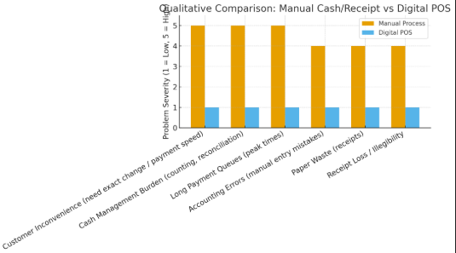

Figure 4: Digital Payment System - Secure, fast, and paperless transactions

**Solution 3: Digital Payment System**

Payment modes of the Food Ordering System include safe payment transactions via credit/debit card, mobile wallet stores, and/or online banking. All transactions are electronically processed with automatic receipt generation sent via the email route. The customers have an easy access to their payment history with tracking of expenses. The system will auto-calculate totals, discounts and/or promotions, and a detailed digital receipt with all accounting information needed for the business. The business employee can now access their meal receipts in his/her account anytime, making expense claims simple and more organized. This solution helps in speeding up the checkout process and removes any underlying cash-related issues [7].

**Conclusion**

The Dalandangan Pizza Ordering System has all the necessary features to transform traditional food service operations by addressing the common problems associated with manual systems. Through digital ordering, real-time tracking, and automated payment processing, the system enhances both customer satisfaction and business efficiency [8]. By making the ordering process simple, transparent, and reliable, it helps reduce operational costs, minimize errors, and generate valuable data for smarter decision-making [9]. Ultimately, the Dalandangan Pizza Ordering System ensures a seamless ordering experience for customers while allowing the business to focus on delivering quality food and excellent service [10].

**TOOLS**

**Python3** Main programming language used for the system.

**Tkinter**  GUI framework for creating the interface.

**Ttkboostrap** Used to enhance Tkinter’s appearance and add modern themes.

**SQLite / MySQL** Backend database for storing user, order, and product information.

**Pillow (PIL)** For loading and displaying images, such as the system logo.

**ReportLab** For generating PDF receipts for customer orders.

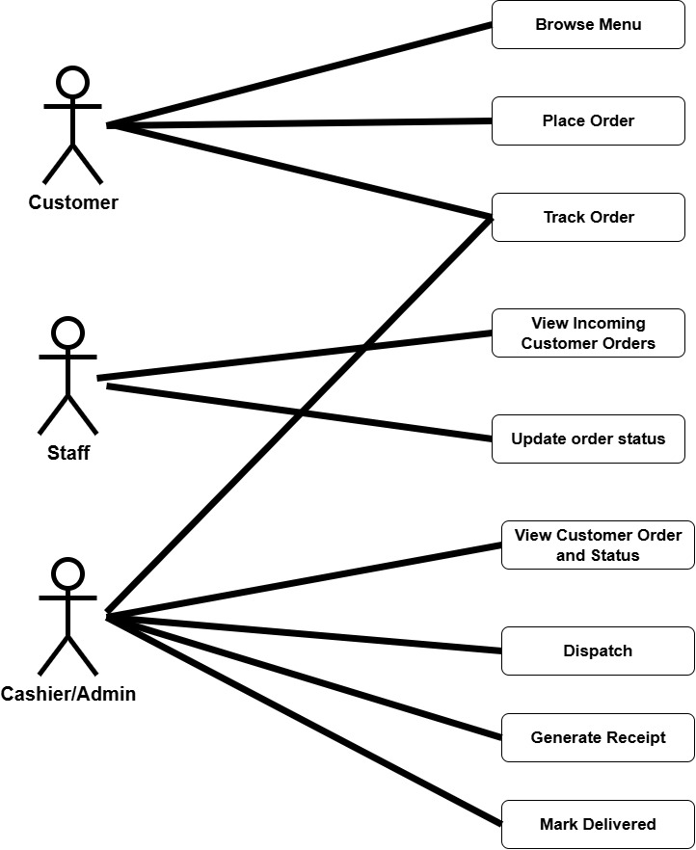**USE CASES**

Figure 5 Dalandangan Pizza Use Cases

**Entity Relationships Diagram (ERD)**

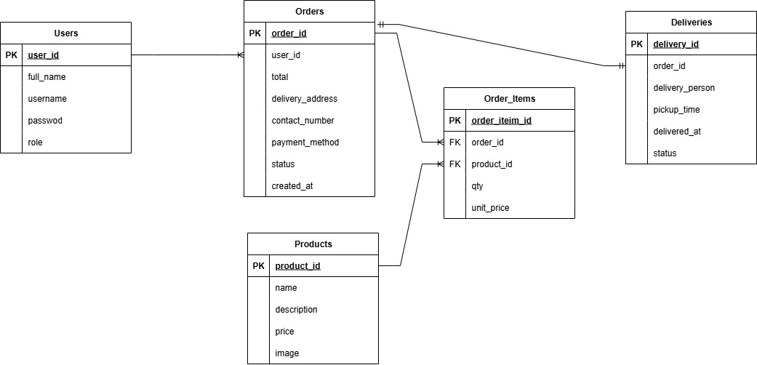

Figure 6 Dalandangan Pizza ERD

**Data Dictionary**

|  |  |  |  |
| --- | --- | --- | --- |
| **Table** | **Field Name** | **Data type** | **Description** |
| **User** | ID | INT (PK) | Unique user ID |
|  | Username | VARCHAR(50) | Login username |
|  | Password_has | VARCHAR(255) | Encrypted password |
|  | Full_name | VARCHAR(100) | Full name of the user |
|  | Role | ENUM('customer','staff','cashier') | Role type |
|  | Created_at | DATETIME | Date account was created |
| **Products** | ID | INT (PK) | Unique product ID |
|  | Name | VARCHAR(100) | Name of pizza |
|  | Price | DECIMAL(10,2) | Price of pizza |
|  | Description | TEXT | Pizza description |
|  | Image_path | VARCHAR(255) | File path of pizza image |
| **Orders** | ID | INT (PK) | Unique order ID |
|  | User_id | INT (FK) | Customer who placed the order |
|  | Total | DECIMAL(10,2) | Total price |
|  | Delivery_address | TEXT | Customer delivery address |
|  | Contact_number | VARCHAR(20) | Customer contact |
|  | Payment_method | ENUM('Cash','Online') | Payment type |
|  | Status | VARCHAR(50 | Order status (Pending, Preparing, etc.) |
|  | Created_at | DATETIME | Time order was placed |
| **Order_items** | ID | INT (PK) | Unique order item ID |
|  | Order_id | INT (FK) | Linked order |
|  | Product_id | INT (FK) | Linked pizza product |
|  | Qty | INT | Quantity ordered |
|  | Unit_price | DECIMAL(10,2) | Price per pizza |
| **Deliveries** | ID | INT (PK) | Unique delivery ID |
|  | Order_id | INT (FK) | Linked order |
|  | Delivery_person | VARCHAR(100) | Assigned delivery person |
|  | Pickup_time | DATETIME | When order was picked up |
|  | Delivered_at | DATETIME | When order was delivered |
|  | Status | VARCHAR(50) | Delivery status (Picked Up, Delivered, etc.) |

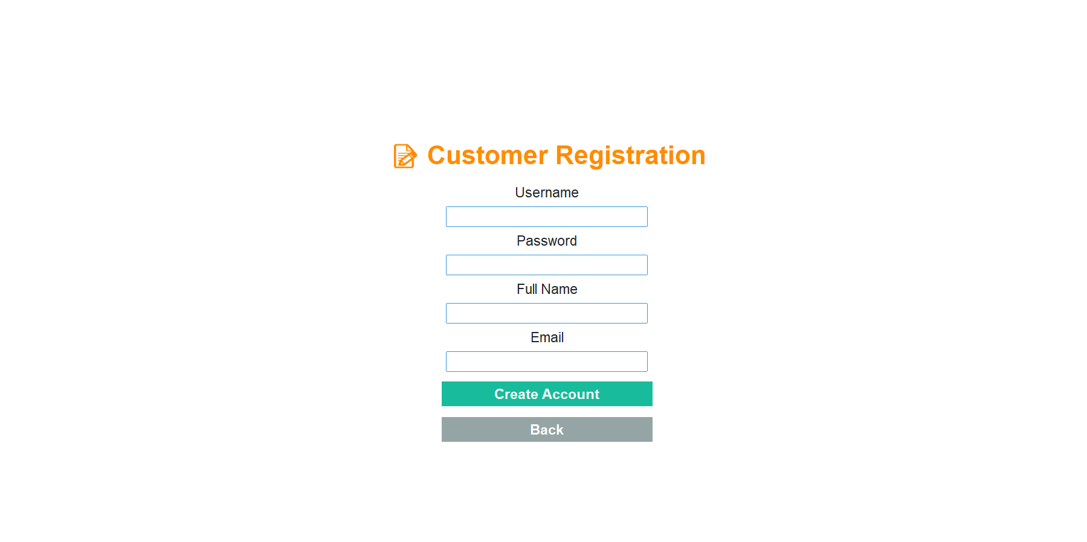

Figure 7: Customer Registration Interface

This page allows new users to create an account by entering their username, password, full name, and email. Once the details are filled in, the user clicks “Create Account” to register or selects “Back” to return to the previous screen. The design is simple and user-friendly, ensuring easy navigation and accessibility for customers.

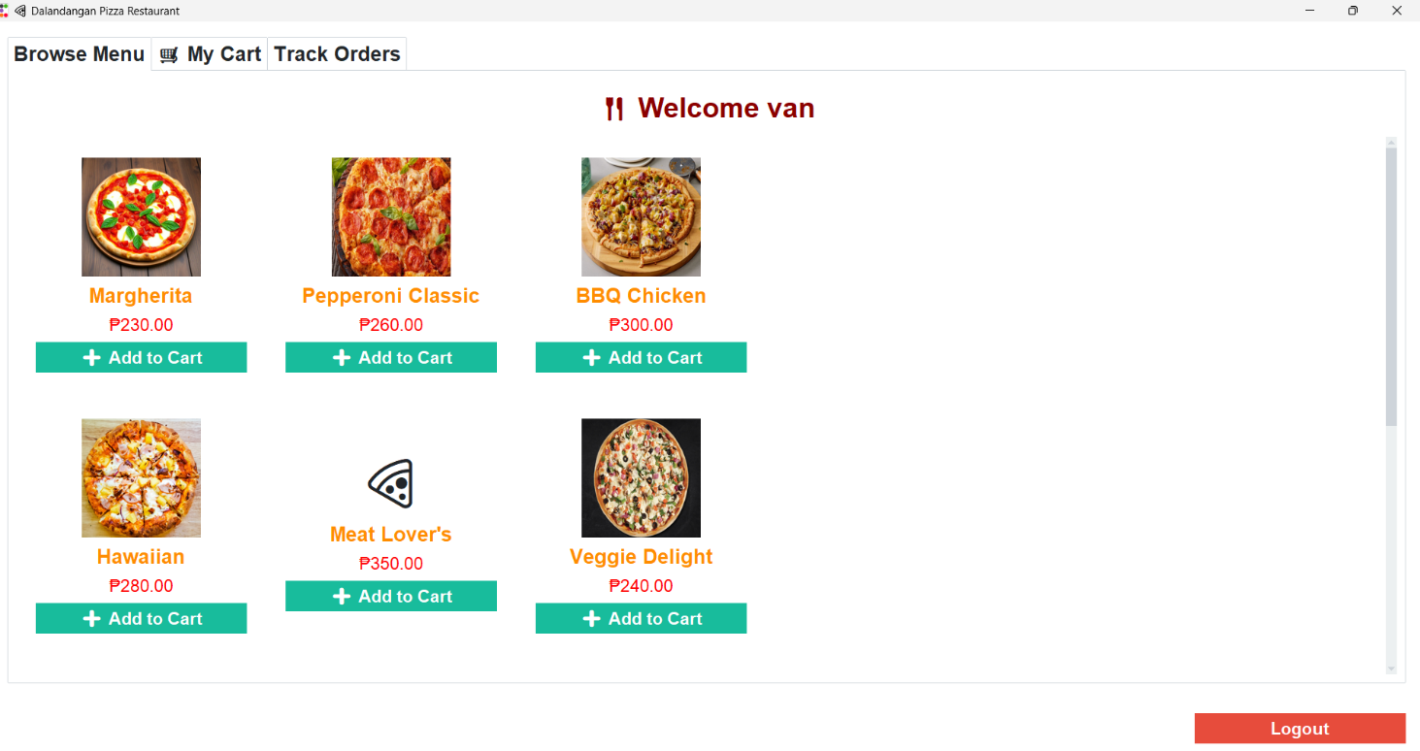

Figure 8: Customer Menu Interface

This screen displays the available pizza options for customers, including product names, prices, and images. Users can easily browse the menu, add items to the cart using the “Add to Cart” button, or navigate to My Cart and Track Orders tabs. The interface also shows a personalized greeting (“Welcome [username]”) and a Logout button for exiting the system. The layout is designed for easy navigation and a smooth ordering experience.

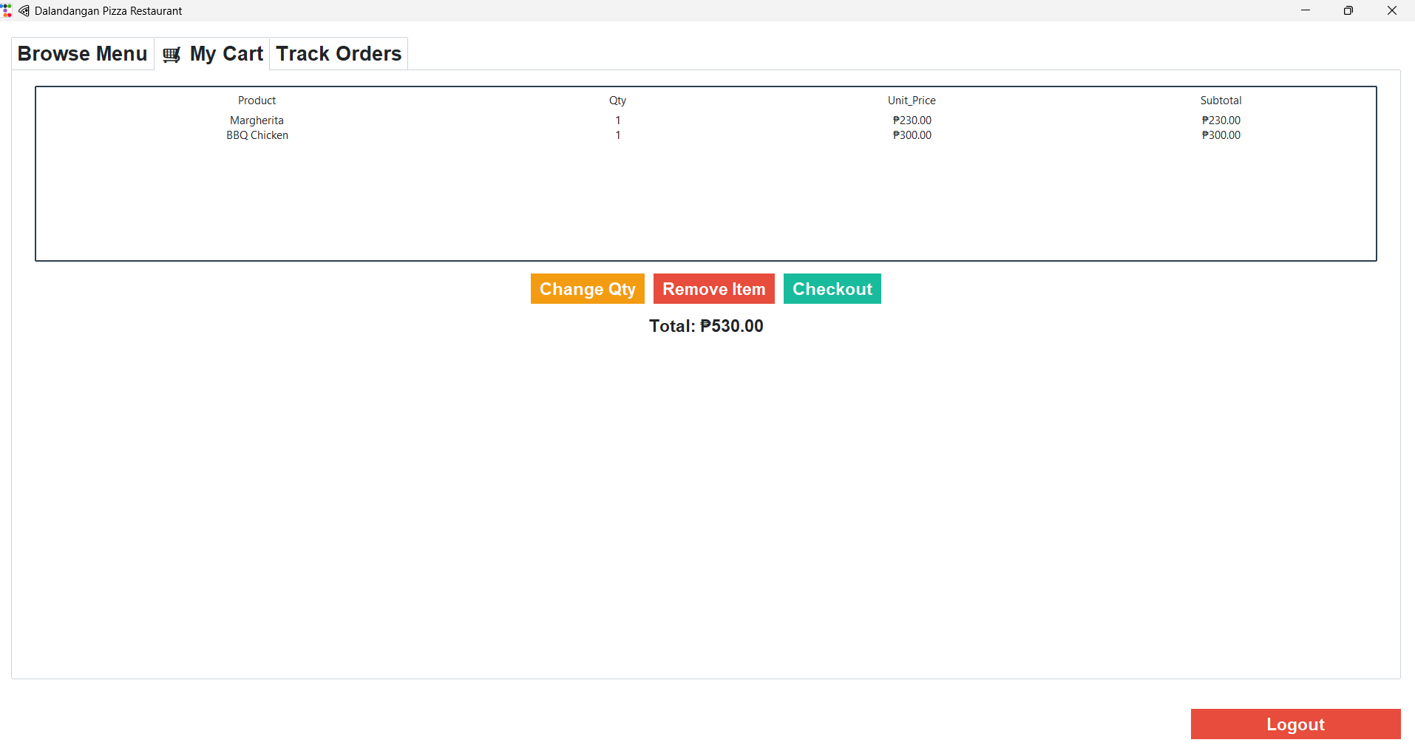

Figure 9: My Cart Interface

This screen displays the list of selected items, including product names, quantities, unit prices, and subtotals. Customers can update item quantities using “Change Qty”, remove items with “Remove Item”, or proceed to payment through the “Checkout” button. The total cost is automatically calculated at the bottom, ensuring clarity and convenience for the user.

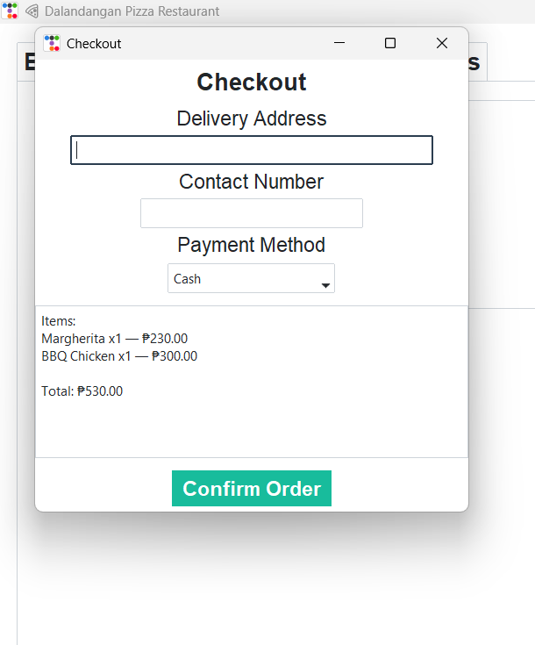

Figure 10: Checkout Interface

This screen enables customers to complete their order by providing a delivery address, contact number, and selecting a payment method (e.g., Cash). It also displays the ordered items with their corresponding prices and the total amount. The “Confirm Order” button finalizes the transaction and submits the order for processing.

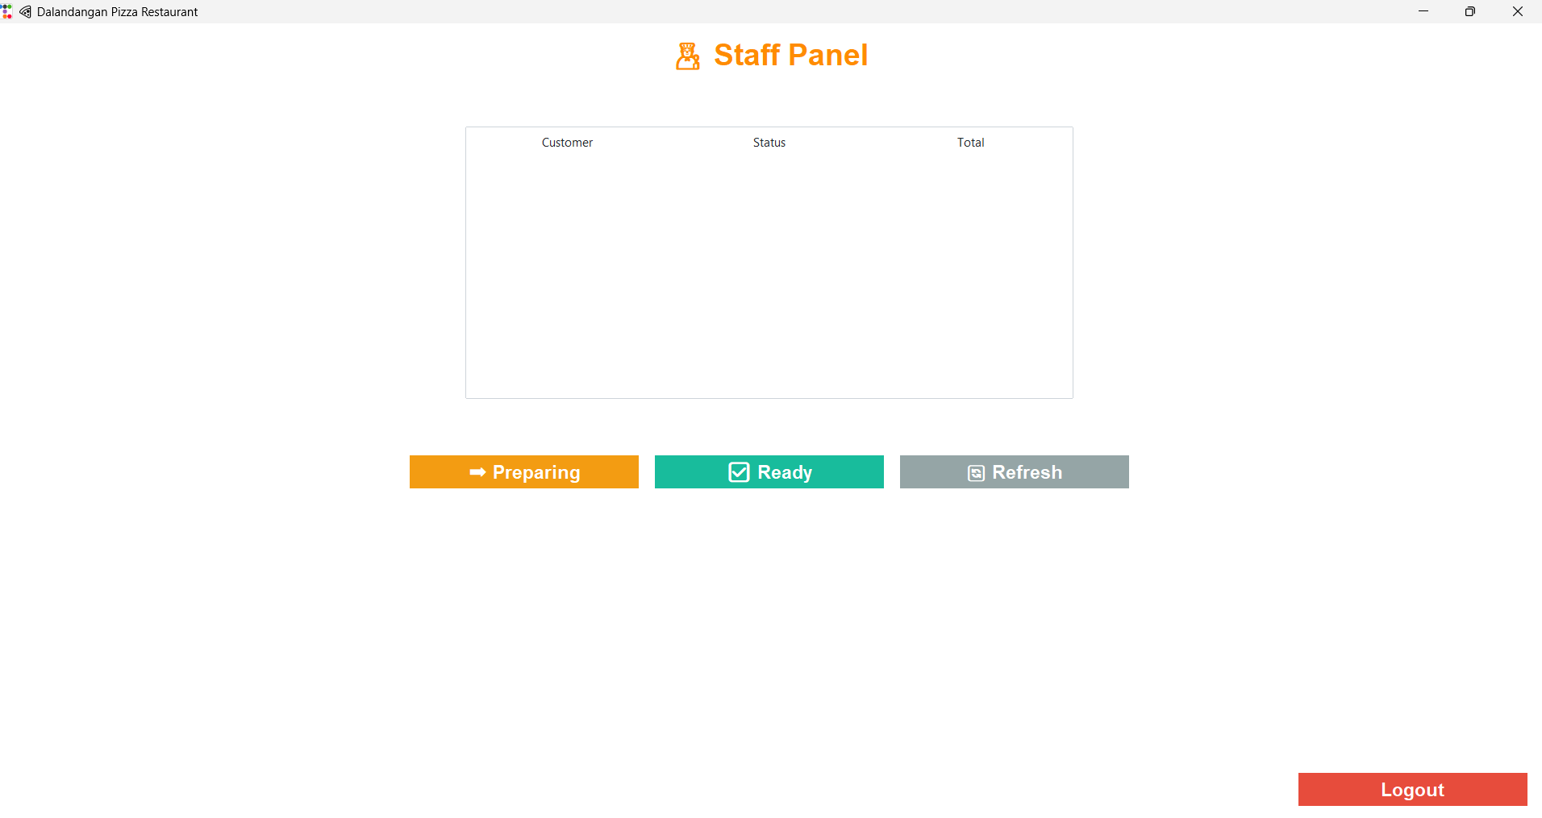

Figure 11: Staff Panel Interface

This screen enables staff members to manage customer orders. The panel displays a list of orders with corresponding customer names, order status, and total amount. Staff can update the order status using the “Preparing” and “Ready” buttons, or refresh the list with “Refresh” to view updated data. The Logout button allows staff to exit the system securely.

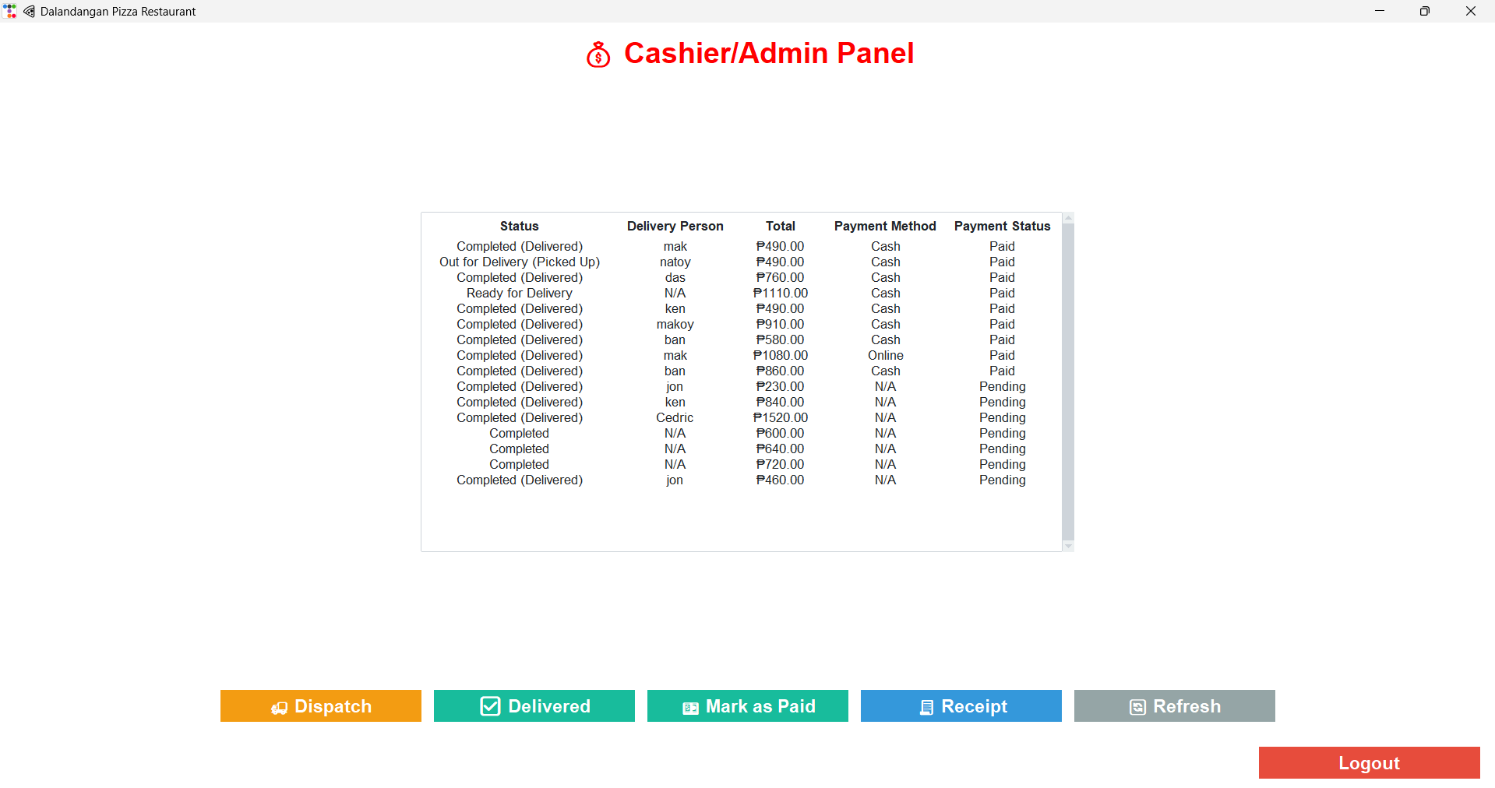

Figure 12 : Cashier/Admin Panel Interface

This interface allows the cashier or admin to manage and track all customer orders. It displays order details including delivery status, delivery personnel, total amount, payment method, and payment status. The panel includes functions such as Dispatch, Delivered, Mark as Paid, Receipt, and Refresh for managing and updating order transactions. The Logout button enables secure exit from the system.

# References

|  |  |
| --- | --- |
| [1] | S. S. a. R. P. A. Kumar, "Digital Transformation in Food Service Industry: A Comprehensive Study," *International Journal of Computer Applications,* vol. 185, no. 47, pp. 12-18, 2023. |
| [2] | K. L. a. P. W. M. Johnson, "Customer Experience in Restaurant Operations: Challenges and Solutions," *Journal of Hospitality Management,* vol. 45, no. 3, pp. 78-85, 2023. |
| [3] | L. W. a. D. Z. S. Chen, "Mobile Food Ordering Systems: Design and Implementation," *IEEE Transactions on Services Computing,* vol. 16, no. 2, pp. 234-245, 2023. |
| [4] | T. D. a. M. G. R. Brown, "Real-time Order Management Systems in Food Service," in *International Conference on Service-Oriented Computing*, 2023. |
| [5] | A. A. a. C. T. J. Smith, "Automated Notification Systems for Restaurant Operations," *ACM Transactions on Internet Technology,* vol. 23, no. 4, pp. 1-19, 2023. |
| [6] | N. C. a. S. R. K. Thompson, "Digital Payment Systems in Small Business Operations," *Journal of Business Research,* vol. 142, pp. 89-98, 2023. |
| [7] | F. Z. a. Y. Y. H. Liu, "Paperless Transaction Systems: Environmental and Economic Benefits," *Environmental Management Journal,* vol. 78, no. 5, pp. 445-452, 2023. |
| [8] | J. W. a. L. P. Martinez, "Comprehensive Digital Solutions for Food Service Industry," *Technology Innovation Management Review,* vol. 13, no. 6, pp. 23-31, 2023. |
| [9] | G. v. Rossum, "Python Programming Language, Python.org," Python Software Foundation (PSF)., 2024. [Online]. |
| [10] | H. P. a. R. Singh, "Adoption of Digital Ordering Platforms in Quick Service Restaurants," *IEEE Access,* vol. 12, pp. 55678-55686, 2024. |